Calculating Low-rise Residential Site Energy Use Intensity (EUI) for the AIA Common App

Overview
This document provides instructions on how to complete the “Measure 5 - Design for Energy” section of the AIA Common App for Design Excellence (AIA Common App) based on data generated by California compliance software for the building project. Post-processing of compliance software output data will be required. Instructions and a simple calculator are provided to perform the post-processing calculations.
The Title 24 Energy Standards are updated every three years, so there will be different code requirements and different compliance software outputs and reports depending on when the building went for permit, as well as the software used for compliance.
This document provides instructions to perform the appropriate calculations on data from reports generated by several versions of the CA compliance software. Click the links in the table of contents below for instructions relevant to your project’s code vintage and building type.

Table of Contents:
- Quick Primer on EUI Metrics
- Instructions for Calculating Site EUI
  - Residential Projects:
    - 2013 Title 24 Standards (permit application dates between July 1, 2014 - December 31, 2016)
    - 2016 Title 24 Standards (permit application dates between January 1, 2017 - December 31, 2019)
    - 2019 Title 24 Standards (permit application dates after January 1, 2020)
- Instructions for Filling Out the AIA Common App
- Reference - EUI Calculation Formulas

Quick Primer on EUI Metrics

Site Energy vs. TDV Metrics
The unit of energy for the performance method compliance software is called Time Dependent Valuation (TDV) energy. It is reported as annual energy use per square foot in kBtu/ft²-yr, sometimes abbreviated to kTDV/ ft²-yr. The concept behind TDV is that energy efficiency measure savings should be valued differently depending on which hours of the year the savings occur, to better reflect the actual costs of energy to consumers, to the utility system, and to society. Thus a TDV multiplier is applied to modeled energy use for each hour of the year. This is consistent for all of the Title 24 Part 6 compliance software for 2013, 2016 and 2019.
However, site energy is NOT the same as this compliance-only TDV metric (even though it also uses units of kBtu/ft²-yr).In order to report site energy EUI, be sure to use the right energy metrics. The instructions below will point you to the correct data.

One More Thing About Metrics
Site energy metrics are often reported in units associated with a specific fuel type. For example, electricity consumption is often reported in kWh or MWh, and natural gas and propane is reported in therms or MBTU. In order to calculate site energy EUI, unit conversion is needed to translate energy consumption to kBTU. These calculations are all handled in the calculator tool. See the reference section at the end of this document for details on all of the calculation formulas.

Instructions for Calculating Site EUI for Low-Rise residential buildings

2013 Title 24 Standards
(permit application dates between July 1, 2014 - December 31, 2016)

EnergyPro Software v6.x
Reports Tab
Print Preview
Figure 1 - EnergyPro ECON-1 report generation
ECON-1
Residential Title 24 Performance
For EnergyPro, we need to gather the conditioned floor area from the CF1R-PRF report, and then gather the Site Energy data from the ECON-1 report. These numbers are then input into the EUI calculator to output the Total EUI.
A. Produce CF1R and ECON-1 reports
The CF1R-PRF-01-E is the formal compliance report that is required for demonstrating code compliance on all low-rise residential projects. The ECON-1 is an optional report generated by EnergyPro, and it tabulates monthly and annual site energy consumption for both electricity and natural gas/propane.
To generate these reports, first we must turn on the form in the ‘Reports’ tab on the left menu bar. Find the ‘Reports’ option in the left-hand menu bar, then under the ‘Residential Title 24 Performance’ item, find the ‘Form CF-1R-PRF-01-E’ and the ‘Form ECON-1 Energy Use’ and check the boxes. Next, click the ‘Print Preview’ button on the top menu bar, and the Report should be generated and automatically opened in your default PDF viewer (e.g. Adobe Acrobat).
See Figure 4 - EnergyPro ECON-1 report generation for a visual guide.
Figure 2 - Finding Total Conditioned Floor Area

EnergyPro: Finding Conditioned Floor Area in CF1R-PRF
When the PDF opens, we will first scroll to the top of the CF-1R-PRF-01-E form and locate the ‘GENERAL INFORMATION’ table. Item 14 in the table is the Total Conditioned Floor Area. See Figure 5 - Finding Total Conditioned Floor Area.

EnergyPro: Finding the Site Energy Data in ECON-1
Next, we will find the Site Energy Data from the ECON-1 report. Scroll through the PDF and find the ECON-1 (it’s typically towards the end). Annual Site energy data is located at the bottom of the page. Input the total kWh and therms into the EUI calculator. See Figure 6 - Site Energy in ECON-1
Figure 3 - Site Energy in ECON-1
Scroll to Bottom

CBECC-Res software
For CBECC-Res software, the process for calculating EUI is slightly different than for EnergyPro since CBECC-Res does not produce an ECON-1 report. After the completion of any Performance calculation, CBECC-Res displays a dialogue screen to ask if it should open the compliance report (if it doesn’t, then the ‘Generate Report(s)’ boxes are unchecked in the Project->Analysis tab). You want to select the option which opens that compliance report, which will then automatically open in your default PDF viewer. CBECC-Res will also automatically open an ‘Analysis Results’ screen. We will gather the EUI factors from both the CF1R-PRF compliance report and the Analysis Results screen.

CBECC-Res: Finding Conditioned Floor Area
We will collect the Conditioned Floor Area directly from Box 14 in the General Information table in the CF1R-PRF report. See Figure 4 - Finding Conditioned Floor Area
Figure 4 - Finding Conditioned Floor Area

CBECC-Res: Finding Site Energy Data
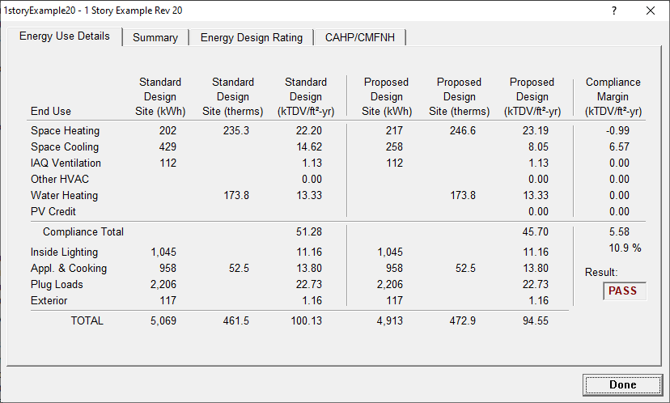
Figure 5 - Site Energy in Analysis Results
kWh
therms
Site Energy is displayed in the ‘Energy Use Details’ screen of the Analysis Results. This screen automatically appears upon completion of a calculation, and can be regenerated by selecting the top ‘Tools’ menu in the CBECC-Res interface and finding ‘Review Analysis Results’ option.
From the Energy Use Details screen we will gather the kWh and therm totals in the Proposed Design case. Input these numbers into the EUI Calculator.
See Figure 5 - Site Energy in Analysis Results

2016 Title 24 Standards
Reports Tab
Print Preview
Energy Use Summary Report
Residential Title 24 Performance
Figure 6 - EnergyPro v7.x report generation
(permit application dates between January 1, 2017 - December 31, 2019)

EnergyPro Software v7.x
Note—these instructions are different from EnergyPro v 6.x. This is because unlike version 6, the ECON-1 report in version 7 will indicate net Site Energy, and not gross Site Energy. Therefore, we’re going to use the ‘Energy Use Summary’ report instead.
For EnergyPro, we need to gather the conditioned floor area from the CF1R-PRF report, and then gather the Site Energy data from the Energy Use Summary report. These numbers are then input into the EUI calculator to output the Total EUI.

EnergyPro: Produce CF1R and Energy Use Summary Reports

The CF1R-PRF report is the standard code compliance report from which we’ll get the conditioned floor area. The Energy Use Summary report is an optional report generated by EnergyPro, and it tabulates annual site energy consumption for both electricity and natural gas/propane.
To generate these reports, first find the ‘Reports’ option in the left-hand menu bar, then under the ‘Residential Title 24 Performance’ item find the ‘Form CF-1R-PRF-01-E’ and the ‘Energy Use Summary’ boxes and check them. Next, click the ‘Print Preview’ button on the top menu bar, and the Report should be generated and automatically opened in your default PDF viewer (e.g. Adobe Acrobat). See Figure 6 - EnergyPro v7.x report generation for a visual guide.
Figure 7 - Finding Total Conditioned Floor Area

EnergyPro: Finding Conditioned Floor Area in CF1R-PRF
When the report PDF opens, we will first scroll to the top of the CF-1R-PRF-01-E form and locate the ‘GENERAL INFORMATION’ table. Item 14 in the table is the Total Conditioned Floor Area. See Figure 7 - Finding Total Conditioned Floor Area.

EnergyPro: Finding the Site Energy Data in Energy Use Summary Report
Next, we will find the Site Energy Data from the Energy Use Summary report. Scroll through the PDF and find the report (it’s typically towards the end). You will see tabs for Electricity and Fossil Fuel. See Figure 8 - Site Energy in Energy Use Summary
Electricity: If the Renewables is not zero, then you need to add the kWh of renewables back into the Total kWh. Enter the Total kWh into the EUI Calculator.
Natural Gas/Propane: Look for total therms under the Fossil Fuel tab and enter this number into the EUI Calculator.
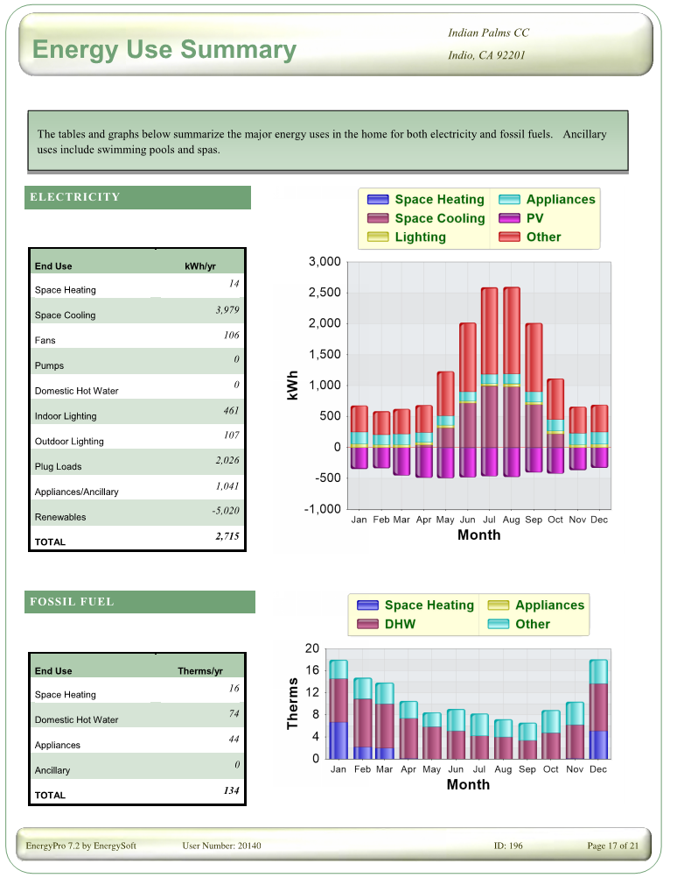
Figure 8 - Site Energy in Energy Use Summary
Total kWh (2715)
Renewables (-5020)
Total Therms (134)
Note—if renewables is not ‘0’, then the renewables offset needs to be added back into the Total in order to get a Gross EUI number.
In this example, the Total Gross kWh is 7735 (2715 + 5020)

CBECC-Res 2016 software
Note—these are the exact same instructions as for CBECC-Res 2013
After the completion of any performance calculation, CBECC-Res displays a dialogue screen to ask if it should open the compliance report (if it doesn’t, then the ‘Generate Report(s)’ boxes are unchecked in the Project->Analysis tab). You want to select the option which opens that compliance report, which will then automatically open in your default PDF viewer. CBECC-Res will also automatically open an ‘Analysis Results’ screen. We will gather the EUI factors from both the CF1R-PRF compliance report and the Analysis Results screen.

CBECC-Res: Finding Conditioned Floor Area
We will collect the Conditioned Floor Area directly from Box 14 in the General Information table in the CF1R-PRF report. See Figure 9 - Finding Conditioned Floor Area
Figure 9 - Finding Conditioned Floor Area

CBECC-Res: Finding Site Energy Data
Figure 10 - Site Energy in Analysis Results
kWh
therms
Site Energy is displayed in the ‘Energy Use Details’ screen of the Analysis Results. This screen automatically appears upon completion of a calculation, and can be regenerated by selecting the top ‘Tools’ menu in the CBECC-Res interface and finding ‘Review Analysis Results’ option.
From the Energy Use Details screen we will gather the kWh and therm totals in the Proposed Design case. See Figure 10 - Site Energy in Analysis Results

2. Enter Data into EUI Calculator
Enter these values into the calculator tool to calculate site energy EUI. An example of the calculator inputs and outputs is shown below in Figure 11. The calculator also has additional tables to calculate a ‘Net EUI’ after factoring in renewable generation.

EUI Calculator
Input Values Here:
Building Area - Conditioned (ft2) | 2,000.0
Proposed Design - Electricity (kWh) | 10,000.0
Proposed Design - Nat Gas/Propane (therms) | 500.0
Calculated Values:
Proposed Design Gross EUI (kBtu/ft2-yr) | 19.6
Figure 11 - EUI Calculator Example

Instructions for Filling Out the AIA Common App
Use the values generated by the calculator tool to fill in the highlighted portions of the AIA Common App for Design Excellence according to the instructions below.

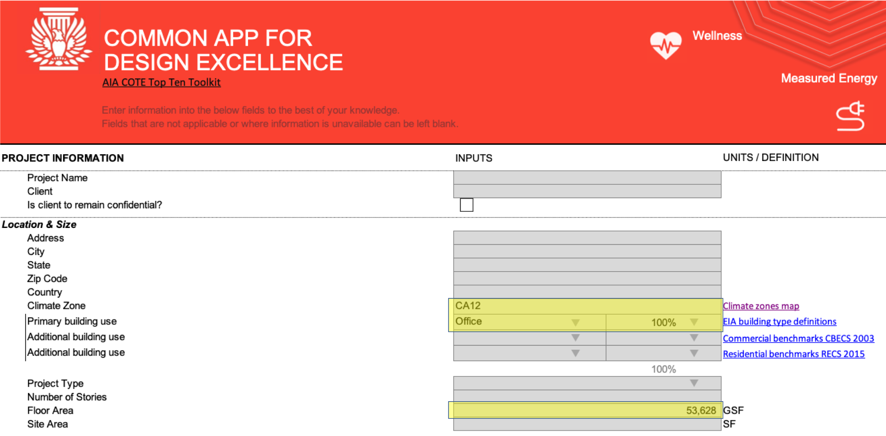
Figure 12: AIA Common App: “Project Information”

Project Information - Input Descriptions:
The following inputs are used to calculate your project’s Benchmark EUI for the 2030 Challenge.
- Climate Zone: Select your project’s California climate zone from the drop-down menu. This value should be taken from Table A of the compliance form as shown above in Figure 12.
- Primary building use: Select the building type from the drop-down menu that represents your project’s primary use. If this is the only use of the building, select “100%” from the adjacent cell in the form. For mixed-use buildings, select an appropriate percentage of building floor area for this building use type, and then define “additional building use(s)” and corresponding percentage of floor area for these additional uses. Note: this information is not reported on the Title 24 compliance forms, but should be available from the project design team.
- Floor Area: Enter your project’s floor area, which is the sum of conditioned and unconditioned floor areas.

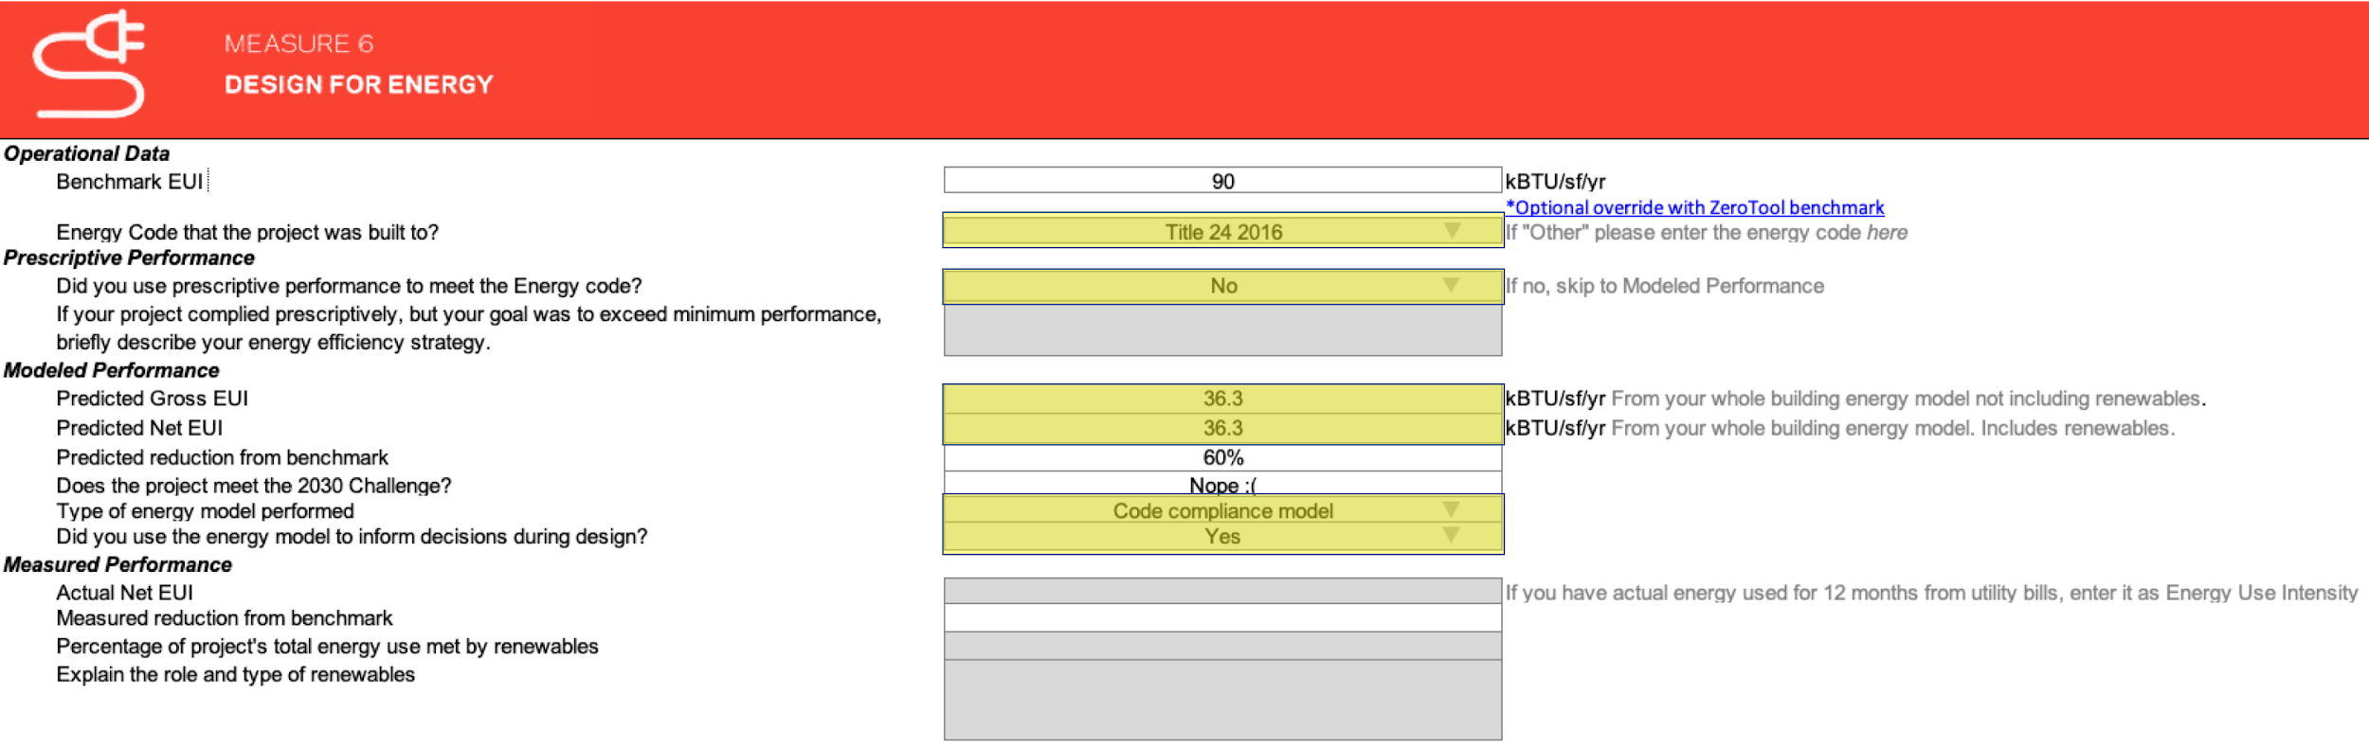
Figure 13: AIA Common App "Measure 6 - Design for Energy"

Design for Energy - Input Descriptions:
The following inputs are used to calculate your project’s Benchmark EUI for 2030 Commitment reporting.
- Benchmark EUI: This is not an input value - it is automatically calculated based on the building type and climate zone inputs in the “Project Information” section of the AIA form. Your project’s EUI will be compared against this benchmark to determine if it meets the 2030 Challenge.
- Energy Code that the project was built to?: Select the appropriate version of the energy code from the drop-down menu.
- Did you use prescriptive performance to meet the energy code?: Select “No” from the drop-down menu.
- Predicted Gross EUI: Enter your project’s Proposed Design EUI as calculated by the EUI Calculator.
- Predicted Net EUI: If your project includes renewable energy generation, you may subtract the EUI of generated renewable energy from the Predicted Gross EUI. Refer to AIA guidelines on how to account for renewable energy. Note that this value is not reported on Residential Title 24 compliance forms and must be calculated using a separate analysis. If there is no renewable generation on your project, this value should equal the Predicted Gross EUI.
- Predicted reduction from benchmark; Does this project meet the 2030 challenge?: These are not input values - they are automatically calculated based on a comparison of the Benchmark EUI to the Predicted Net EUI.
- Type of energy model performed: Select “Code compliance model” from the drop-down menu. Note: if your project also utilized another energy model (e.g. for LEED or design decision making), you may select “Energy performance model”; however, the input values from an alternate (non-compliance) model will come from a different set of reports and instructions are not included in this document. Please consult the project’s energy modeler.
- Did you use the energy model to inform decisions during design?: If your project used multiple energy modeling iterations to select or refine design features with a goal of reducing energy or meeting a specific performance target, select “Yes. ” If a single compliance model was run to document the project’s performance or if iterations of the model were primarily focused on passing the code requirements, select “No.”

Reference - EUI Calculation Formulas
The following formulas are used by the calculator tool to calculate site energy EUI:
Convert Electricity MWh to kBTU:
$$Elec{}_{kBTU}^{}=Elec{}_{MWh} * 3,412$$
Convert Electricity kWh to kBTU:
$$Elec{}_{kBTU}^{}=Elec{}_{kWh} * 3.412$$
Convert Natural Gas MBtu to kBTU:
$$Gas{}_{kBTU}^{}=Gas{}_{MBTU} * 1,000$$
Convert Natural Gas Therms to kBTU:
$$Gas{}_{kBTU}^{}=Gas{}_{therms} * 10$$
Calculate site EUI:
$$EUI=(Elec{}_{kBTU} + Gas{}_{kBTU}) / (FloorArea{}_{conditioned} +FloorArea{}_{unconditioned})$$

Acknowledgements
This document and the EUI calculator were developed by Lucas Morton and Model Efficiency on behalf of AIA CA and Pacific Gas and Electric’s Pacific Energy Center. Elizabeth Smithwick (CEA) provided peer review.

